**Experiment : 4.3 Paul Thomas 30 S3 CSB**

**Program**

| import javax.swing.*;  import java.awt.event.*;  class Calc implements ActionListener  {  JFrame f;  JTextField t;  JButton b1,b2,b3,b4,b5,b6,b7,b8,b9,b0,bdiv,bmul,bsub,badd,bdec,beq,bdel,bclr;    static double a=0,b=0,result=0;  static int operator=0;    Calc()  {  f=new JFrame("Calculator");  t=new JTextField();  b1=new JButton("1");  b2=new JButton("2");  b3=new JButton("3");  b4=new JButton("4");  b5=new JButton("5");  b6=new JButton("6");  b7=new JButton("7");  b8=new JButton("8");  b9=new JButton("9");  b0=new JButton("0");  bdiv=new JButton("/");  bmul=new JButton("*");  bsub=new JButton("-");  badd=new JButton("+");  bdec=new JButton(".");  beq=new JButton("=");  bdel=new JButton("Delete");  bclr=new JButton("Clear");  t.setBounds(30,40,280,30);  b7.setBounds(40,100,50,40);  b8.setBounds(110,100,50,40);  b9.setBounds(180,100,50,40);  bdiv.setBounds(250,100,50,40);  b4.setBounds(40,170,50,40);  b5.setBounds(110,170,50,40);  b6.setBounds(180,170,50,40);  bmul.setBounds(250,170,50,40);  b1.setBounds(40,240,50,40);  b2.setBounds(110,240,50,40);  b3.setBounds(180,240,50,40);  bsub.setBounds(250,240,50,40);  bdec.setBounds(40,310,50,40);  b0.setBounds(110,310,50,40);  beq.setBounds(180,310,50,40);  badd.setBounds(250,310,50,40);  bdel.setBounds(60,380,100,40);  bclr.setBounds(180,380,100,40);  f.add(t);  f.add(b7);  f.add(b8);  f.add(b9);  f.add(bdiv);  f.add(b4);  f.add(b5);  f.add(b6);  f.add(bmul);  f.add(b1);  f.add(b2);  f.add(b3);  f.add(bsub);  f.add(bdec);  f.add(b0);  f.add(beq);  f.add(badd);  f.add(bdel);  f.add(bclr);  f.setLayout(null);  f.setVisible(true);  f.setSize(350,500);  f.setDefaultCloseOperation(JFrame.EXIT_ON_CLOSE); | f.setResizable(false);  b1.addActionListener(this);  b2.addActionListener(this);  b3.addActionListener(this);  b4.addActionListener(this);  b5.addActionListener(this);  b6.addActionListener(this);  b7.addActionListener(this);  b8.addActionListener(this);  b9.addActionListener(this);  b0.addActionListener(this);  badd.addActionListener(this);  bdiv.addActionListener(this);  bmul.addActionListener(this);  bsub.addActionListener(this);  bdec.addActionListener(this);  beq.addActionListener(this);  bdel.addActionListener(this);  bclr.addActionListener(this);  }    public void actionPerformed(ActionEvent e)  {  if(e.getSource()==b1)  t.setText(t.getText().concat("1"));  if(e.getSource()==b2)  t.setText(t.getText().concat("2"));  if(e.getSource()==b3)  t.setText(t.getText().concat("3"));  if(e.getSource()==b4)  t.setText(t.getText().concat("4"));  if(e.getSource()==b5)  t.setText(t.getText().concat("5"));  if(e.getSource()==b6)  t.setText(t.getText().concat("6"));  if(e.getSource()==b7)  t.setText(t.getText().concat("7"));  if(e.getSource()==b8)  t.setText(t.getText().concat("8"));  if(e.getSource()==b9)  t.setText(t.getText().concat("9"));  if(e.getSource()==b0)  t.setText(t.getText().concat("0"));  if(e.getSource()==bdec)  t.setText(t.getText().concat("."));  if(e.getSource()==badd)  {  a=Double.parseDouble(t.getText());  operator=1;  t.setText("");  }  if(e.getSource()==bsub)  {  a=Double.parseDouble(t.getText());  operator=2;  t.setText("");  }  if(e.getSource()==bmul)  {  a=Double.parseDouble(t.getText());  operator=3;  t.setText("");  }  if(e.getSource()==bdiv)  {  a=Double.parseDouble(t.getText());  operator=4;  t.setText("");  }  if(e.getSource()==beq)  {  b=Double.parseDouble(t.getText());  switch(operator)  { | case 1: result=a+b;  break;  case 2: result=a-b;  break;  case 3: result=a*b;  break;  case 4: result=a/b;  break;  default: result=0;  }  t.setText(""+result);  }  if(e.getSource()==bclr)  t.setText("");  if(e.getSource()==bdel)  {  String s=t.getText();  t.setText("");  for(int i=0;i<s.length()-1;i++)  t.setText(t.getText()+s.charAt(i));  }  }    public static void main(String...s)  {  new Calc();  }  } |
| --- | --- | --- |

Program

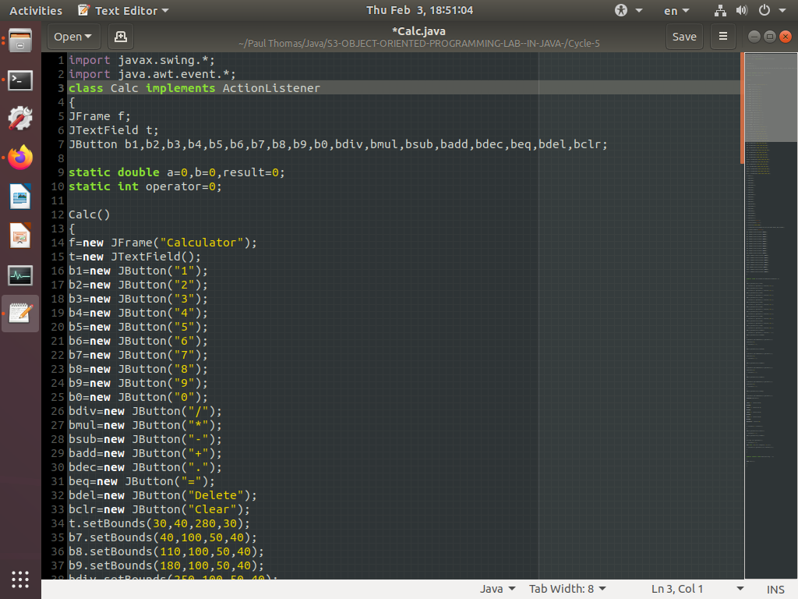

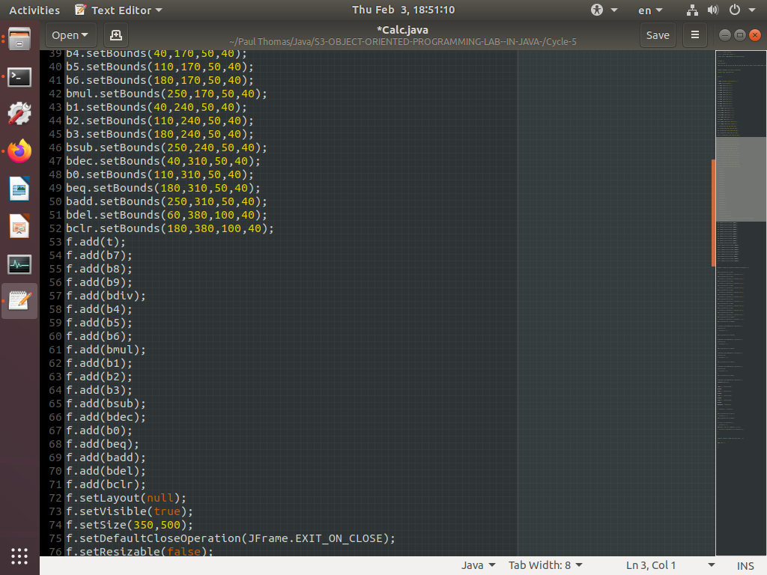

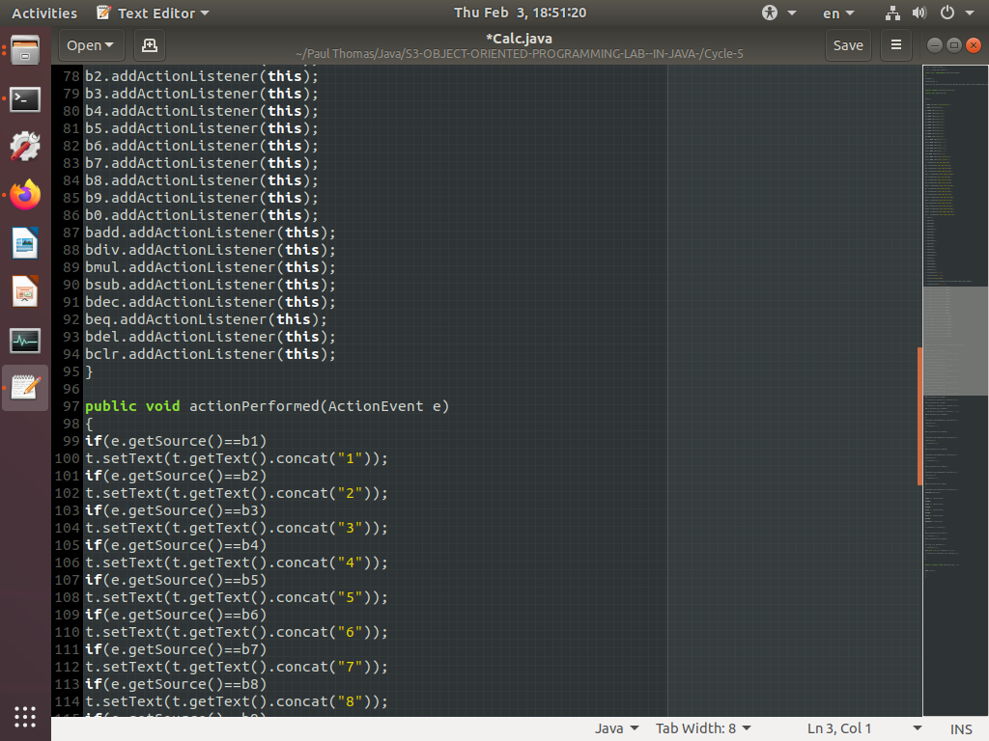

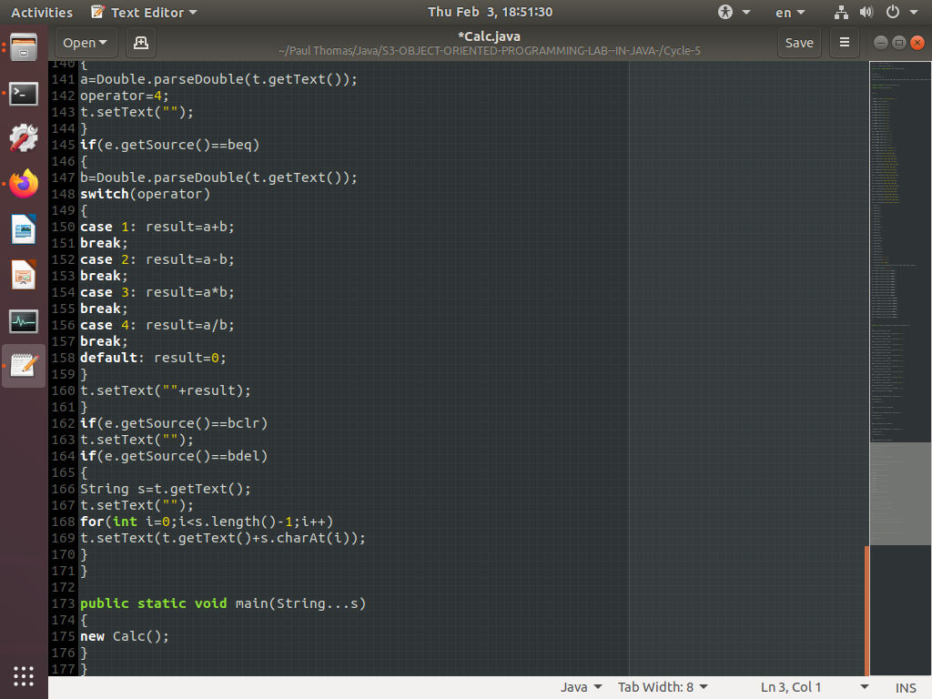

Output

